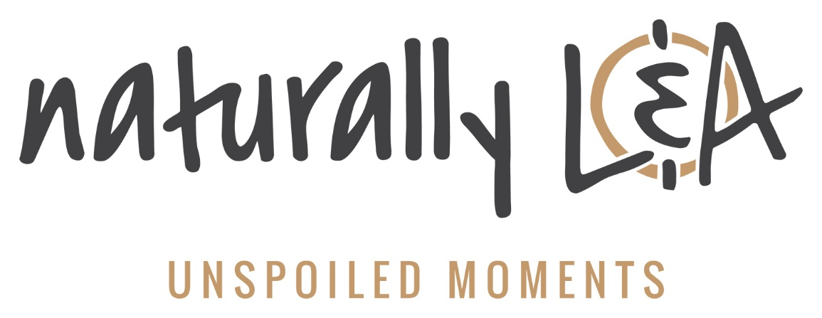
Tourism Activation Fund

Hidden gems and unspoiled moments are found in every corner of Lennox & Addington County. Here in L&A we offer breathtaking rural landscapes, a rich history and lifelong memories that are Naturally L&A.
We also offer a number of unique tourism products and are home to a variety of top-notch events that are enjoyed by both residents and visitors alike.
Lennox & Addington Economic Development Office is offering the opportunity to receive funding for new event creation, event enhancement or new / enhanced tourism product development. Funding will be equally available for tourism businesses and event organizers in each of Lennox and Addington’s four partner municipalities: Township of Addington Highlands, Town of Greater Napanee, Loyalist Township and the Township of Stone Mills.
Examples of event enhancements include incorporating live music, local food or other exciting additions that will draw visitors from further afield and make for a more memorable experience. Potential new events could include music concerts, sporting events or other unique offerings.
New tourism products include developing activities with untapped potential. Examples include new attractions (i.e. stargazing tourism), themed tours (i.e. haunted walks), or business collaborations that add to the visitor experience (i.e. butter tart trail).
Applicants are strongly encouraged to discuss their project, questions and eligibility before applying by contacting Rob Plumley, Community Development Officer at 613-354-4883 ext. 3271.

Tourism Activation Program Guidelines

Lennox & Addington County is offering Tourism Activation Funding to create truly unique experiences. This initiative focuses on supporting projects that are unique and result in marketing exposure and visitor attraction for Lennox and Addington.
Please see below for criteria guidelines and more information.

Eligibility

Eligible organizations include:
- Festival and Event Organizers
- Tourism Enterprises, Businesses and Community Groups (as individual organizations or as a group) such as Arts & Culture, Heritage, Agri-Culinary, Sports, etc.
The project must be visitor-friendly and located within Lennox & Addington County. The project must be a new or enhanced experience. It is expected that organizations have their own budget to put toward the project and to match the potential funding.

Ineligible requests include:
- Capital/infrastructure expenses
- Regular operational expenses
- Charitable contributions
- Municipal governments are not eligible to apply.

Evaluation Criteria

The Selection Committee, consisting of members of the Lennox & Addington County Economic Development Coalition, will use the following criteria to evaluate each application:

Selection Criteria:
- New or enhanced experience
- Unique, authentic experience
- Potential of social media engagement
- Feasibility
- Appeals to both local residents and visitors
- Potential to attract out-of-town visitors
- Potential of overall economic benefit to Lennox & Addington County
- Level of collaboration with other stakeholders
- Marketing/promotional support provided
Please note that priority will be given to applications that HAVE NOT received Tourism Activation Funding in previous years.
Events/project must be completed by December 31, 2020.

Selection Process & Due Diligence

Selection Process
All applications go through a process of screening against the eligibility criteria before being assessed by the Selection Committee. The Selection Committee will meet to discuss the submissions and agree upon a final short-list of applications.

Due Diligence
Before granting final approval, Lennox & Addington County will undertake due diligence on the lead organizations. The main purpose of this is to determine capability and readiness of the lead organization to deliver the end product.
If successful, a funding agreement between the lead organization and Lennox & Addington County will be required.

Application Process & Deadlines

Applicants are strongly encouraged to discuss their project, questions and eligibility before applying by contacting Rob Plumley, Community Development Officer at 613-354-4883 ext. 3271.
Proposals must be submitted using the form below. The deadline to receive applications is Friday, February 28, 2020 at 4pm.

Tourism Activation Fund Application Form

Before completing the application below, applicants are strongly encouraged to contact Rob Plumley, Community Development Officer for Lennox & Addington County, to discuss the project in detail. Rob can be reached at 613-354-4883 ext. 3271.

General Information:
Contact Name

Organization Name
(if applicable)
Phone

Email

Address

Tell Us a Bit About Your Business/ Organization

Project Type | - New Event | - Event Enhancement | - New Product
Municipality where project/event takes place (select all that apply) | - Township of Addington Highlands  - Town of Greater Napanee  - Loyalist Township  - Township of Stone Mills

Project Details:
Project/Event Name

Event Location(s)
(if applicable)

Provide a brief description of the experience.
Describe your project/event idea.

What are the dates and duration of the experience?
Include a timeline of key milestones for the duration of the project.

Is this a recurring event or experience? | - Yes | - No
Who are the key players responsible for planning and executing the project?

What type of marketing support will be used to promote the experience?

How will the project leverage social media engagement?

How will project success be measured?

What are the risks associated with the event/experience?
(e.g. weather, permitting, minimum attendance requirements, etc.)? What are your contingency plans?

Budget:
Provide a project budget using the table below.
The totals provided for Total Project Budget and Total Project Financing should be equal. Outline all expenses and financing sources for the project.

Note that the maximum contribution from Lennox & Addington County is $2,500. Costs are inclusive of HST.
Project Budget |  | Project Financing
Items | Cost | Funding Source | Amount
 |  | L&A County Contribution
 |  | Organizer Contribution
Total Budget |  | Total Contribution

Submission Details:
I, The Applicant, hereby certify that the information shown in this application is a complete and true declaration.
- Yes
I, The Applicant, am authorized to submit this application on behalf of the project organizer(s).
- Yes

Applicant Name: |  | Date:
Please email the completed application to:
Rob Plumley
Community Development Officer
Lennox & Addington County
rplumley@lennox-addington.on.ca
For more information, please call Rob at 613-354-4883 ext. 3271.

